**Daily Scrum or Standup Meeting**

Team name: _____Hellz Kittens_________

Scrum Master: _____Griffin Hackley_______

Date:__________10-30-2019___________

|  |  |  |  |
| --- | --- | --- | --- |
| **Team Member** | **What did you do since the last scrum?** | **What do you plan to do before the next scrum?** | **What obstacles do you have?** |
| Griffin Hackley | Planning | Ability to upload images to database | Not a lot of time |
| Jack Miranda | Registration form | Implementing registered user bidding on existing auctions | Making sure everything works with existing code |
| Gavin Reid | Completed item model | Another item to be determined | Still learning Django |
| Laryssa Revelli | Added to models and integrated them with auction page, started user view of items page | Finish user bidding and viewing on items | Sick baby, no sleep |
|  |  |  |  |

# Burndown

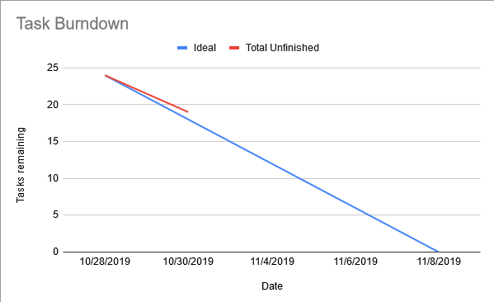

# Screenshot of you project board

